* Genre: 2D top-down RPG (I know you said no RPG but bear with me)
* Setting: Medieval time in an imaginary country, the game is centered around the idea of alchemy
* Story: the story involves a young alchemist, on his way to find the ultimate goal of alchemy: finding the philosopher stone. There will be 4 chapters (for now): the 1st one is the tutorial, where the master teaches the player simple things. Chapter 2 is when the player starts their journey and ends in Chapter 4. For each chapter, the player unlocks a new alchemy recipe.
  + The main character graduates from Alchemy College and goes on a journey to find the recipe to turn lead into gold so that he can pay off his student loan. He learns ideas based on its region (Water for College, Air for Mountain, Earth for Desert, Fire for Graveyard).
  + Chapter 1 will have the main character learning alchemy recipes on his first day of college (this is how the player learns to craft potions). Then it will jump to the main character finishing college. He heads back to his master’s house and talks. Then there’ll be a knock on the door asking about the MC’s student loans and *MC decides to go on an adventure to find the recipe to turn lead into gold from some of his Masters tales. He learns from someone in the local tavern that alchemy was created in the desert and that the alchemist there may have an idea of how to turn lead into gold.*
  + Chapter 2 will have the MC traveling into the desert. (insert introduction here). The MC witnesses bandits stealing from the desert king and the player has the choice if they want to report the bandits or leave them alone. *The main character learns that not everyone has it going for them in life. (And maybe have him think about who he was before he knew his master?)*
  + Chapter 3 will have the MC traveling to the mountain, but he has to pass through the graveyard. A ghost appears and asks the player for help. The player finds out not only the ghost was a murderer when they were alive, but also that the ghost wants to kill the person that put them in jail. The player is given a choice between helping the ghost kill the person or refusing to help them. The options lead to two different boss battles. *The main characters learn that spite is a powerful feeling(?)*
  + Chapter 4 will have the MC scaling the mountain. There’s a master in the mountain who takes the corpses/ghosts and turns them into golems, but the player is unaware of this. The master knows how to make a philosopher stone that contains the text of how to turn lead into gold. The player finds out that the philosopher stone corrupts the user and will be given a choice to use it or not.
  + Ending: the player is a piece of lead, if choose the good ending, lead to gold, bad then lead to mercury (symbolic thing)
* Additional Maybe Stories:Forest part 2? Or Valley?? In the border crossing between two kingdoms the guards ID the alchemist and learn he is a part of the college. Many people respect the college as their graduates are known for their knowledge. The sergeant asks for the alchemist personally, and so the guards pull the alchemist into his meeting room. The sergeant goes on to tell the alchemist they have been looking for a man from the college for awhile, but they don't specify why they need the alchemist. They forcibly take the alchemist to A Warlord’s Fort. The Warlords ask the young alchemist to find his son, invite to the castle to discuss the details of where his son has disappeared to and where he last was. The Warlord was sure his son was still in his region(the forest village), The borders are super heavily guarded and have long lines of civilians and carts. Since the borders are heavily guarded and the warlord has mobilized all his men at the borders, He doesn't have excess manpower to send a search party into the valley. Plus his reputation and his troop don't have a positive reputation to them as the region was recently conquered. The Warlord offers magical artifacts that could be of interest to the alchemist and safe passage into and out of his region if the alchemist helps find his son.

Fake option 1: The warlord first tries to tempt the alchemist with money if the alchemist denies, then the warlord will offer artifacts has the warlord is ignorant of what the alchemist wants.

option 1: you can decline the barron, He will still have the ability to travel but will have to pay tolls. Option 2: player agrees to help warlord→ The warlord says if the player fails in finding his son He will personally send all his men at the border to come and “kill”/attack the player. The warlord doesn't trust the alchemist though so he sends his personal spy to keep an eye on the alchemist, the alchemist doesnt know he is being followed. Once the alchemist leaves the castle, Most of the warlord men are at the border and in the castle/ fort. Because of the Valley’s Lack of troops stationed in the valley. All hell has broken loose in the Valley. The alchemist fights through bandits, wild magical beasts, and goblins and makes it to the village where there are some old remnant soldiers from before the conquest by the new Warlord renaming the region from Lucia to Kravia . The former captain of the former soldier called Lucians. We find out that the Warlord puts a rug over the former lord and gets all his captains and sergeants to stomp the lord of the area. This hopefully makes the players sympathetic toward the former captain. The captain gives a proposition to the alchemist, finds the warlord's son and sends out the magical dove to let the captain know where he is .The captain says “We will deal it (in a deadpan stare)”. The alchemist finds the dilapidated village, the villages as seen better days clearly. Disease and Famine fills the air of the village and is clearly ravaged by war. The alchemist investigates the tavern to drink, Each alchemist from a college receives a college crested watch to show he is an alchemist. The alchemist flexes his authority by putting a watch on the bar table. The bartender says he doesn't want anything to do with you. The village elder says you should be watching your back with a smile, the seeming random guy in the corner of the tavern gets stabbed by 6 pale-skeletal looking villagers. The village elder says I know why you're here. He leads the alchemist to the where the warlord's son where he is in a dilapidated barn. Then everyone in the tavern follow suit, you see a couple of dead warlords troops- Kravian guards and some villagers. Clearly there was a struggle. The warlords son is clearly a mirror opposite of the warlords. The son says” How can my father do this to these innocence villagers, he said he wouldn't harm these people once we conquer the area. He clearly lied”. You now have 3 options: 1: Help the villagers by fighting the baron and his weak troops in the castle with the villagers aiding, 2: help the baron which kills all the villagers who did this treachery. 3: Help the former captain of the Lucian with dove.

Maps:

* + Chapter 1: Forest town with a college, tavern, and houses with mostly humans and elves
    - associated with water elements
    - Blue color scheme

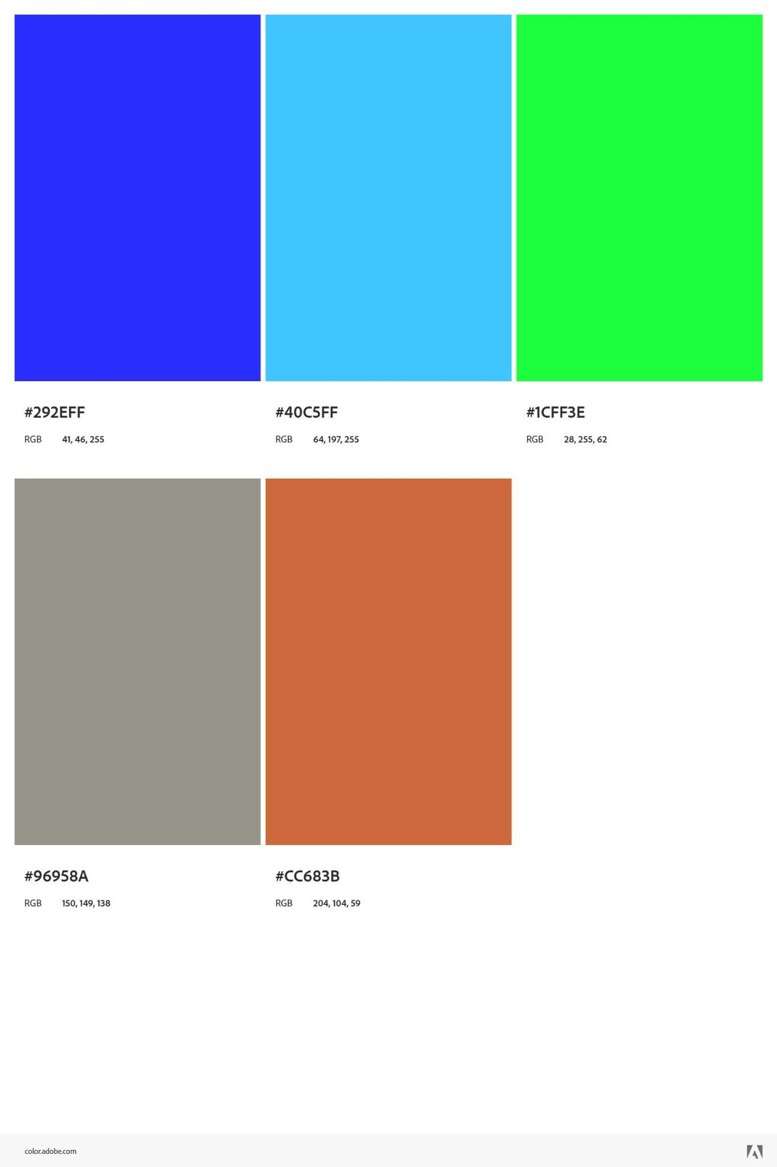

* + Chapter 2: Desert
    - associated with earth elements
    - Yellow/brown/green color scheme

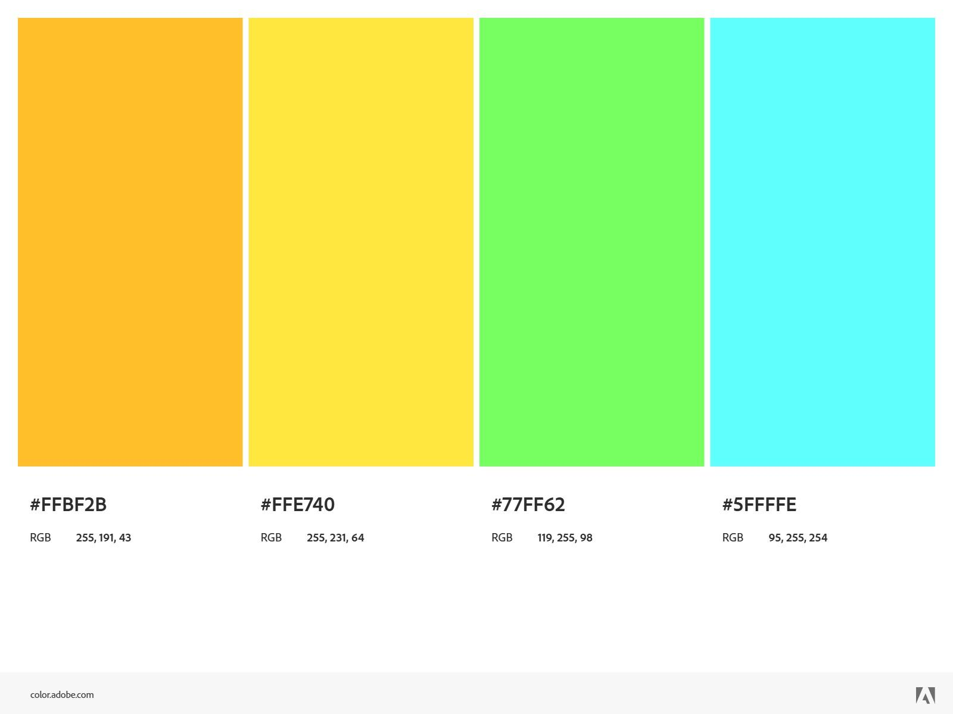

* + Chapter 3: Graveyard
    - associated with fire elements, but since it’s near the mountain region, it has some white/pale color
    - Red/hot color scheme

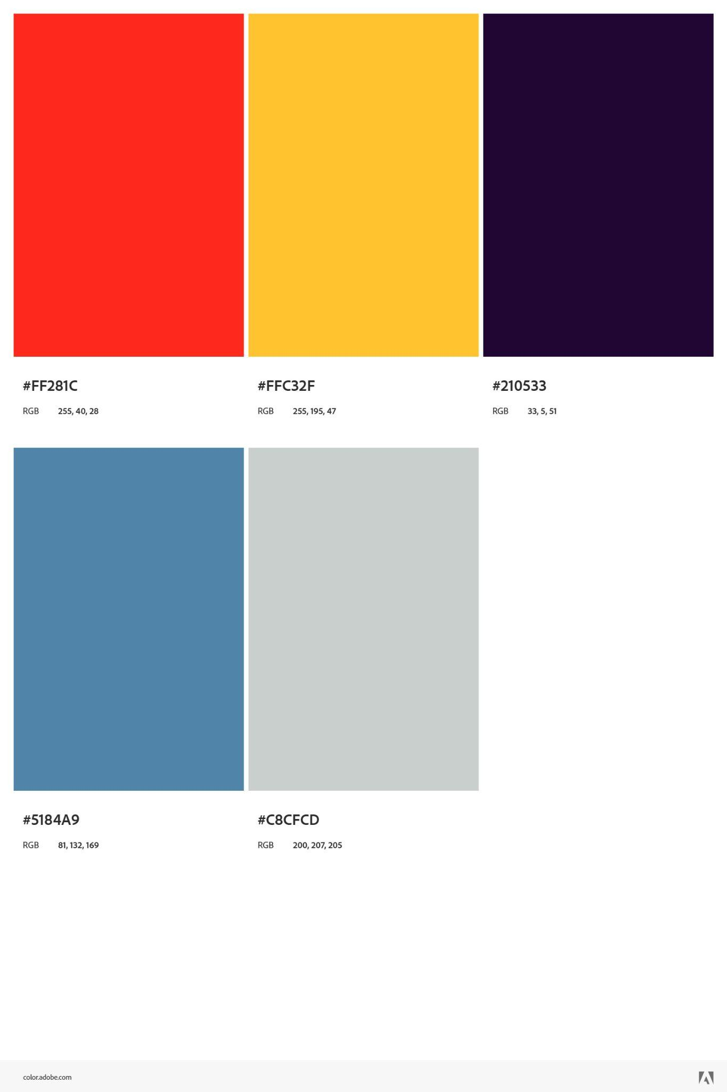

* + Chapter 4: Mountain
    - associated with air elements
    - White/cold color scheme

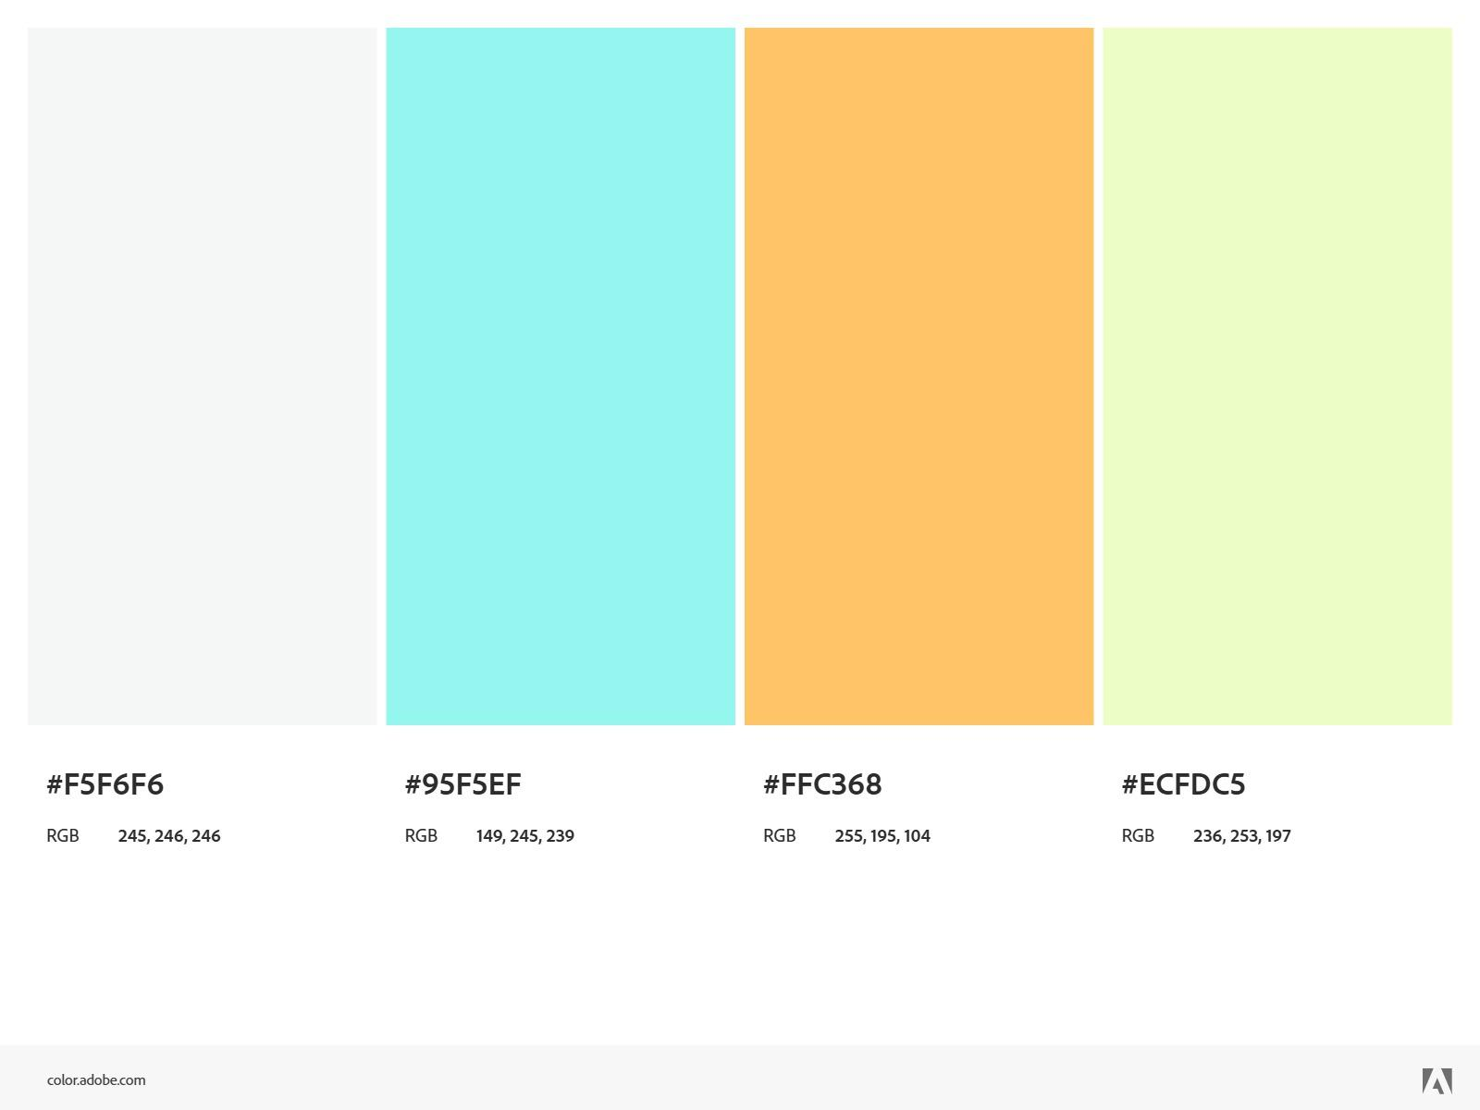

* Characters:
  + MC
    - Name: ???
    - Species: Half-Elf
    - Age: 24
    - Gender: Male
* Art: [ELV Games - itch.io](https://elvgames.itch.io/) (this guy does a lot of top-down art)
* Mechanic:

Sanity system: for now, our idea for Chapter 2 is a journey through the desert, and Chapter 3 is through spooky wood with many tombstones. Both of these “environments” can have an impact on the player's sanity: for chapter 2, the heat of the desert will cause the sanity to be depleted over time, and at some point, hallucination (which is a very common phenomenon in the desert); chap**.** 3, tombstone -> ghost -> affect sanity. Another idea about the sanity system is a resource for the crafting system: ouroboros (a snake eating its tail) is known to be associated with alchemy, and we planned to make it the “god” and the player invoke its power to do alchemy. Sanity levels may affect the quality of alchemy result (it’s still in the air)

* + Crafting system: combine elements into “spells”

ex: combining “the first air (hydrogen - 1st elements in periodic table )” and “air of life (oxygen)” results in “life essence (water)”. So basically, alchemy but can be explained with modern chemistry. crucial recipes will be displayed so the player won’t forget them, but there will be hidden recipes that will only be unlocked if the player can find the correct combination

* Gameplay: Since the genre is RPG, we decided to make it as simple and basic as possible: a very linear story quest, a handful of NPCs that are just there so the world feels less empty, 1 or 2 NPCs that have actual dialogue, but their lines will be simple, like telling the player where to go, give hints… You fight the enemy with your alchemy, and at the end of each chapter, you unlock a new alchemy recipe and then find a boss (so the player can use their new spell and see its interaction)
* Selling points:
  + Crafting system: the player can mess with the elements since it’s the only way for the player to discover hidden recipes.
  + Elements interact with the environment: since the game involves alchemy, we planned to have it interact with the enemy/item. Ex: a locked chest can be unlocked using a key, but since metal becomes brittle when frozen, the player can throw a freeze spell at the chest and hit it to open; or something simple like using water to put out fire.
* Requirements:
  + Player: basic movement, a button that opens inventory, a button that opens the crafting menu, sprint/dodge (?)
  + Enemy: be able to detect and follow the player, hit them, melee and ranged
  + Map/Environmental interaction: Have a minimap
    - Only room for the necessary purposes:
    - Desert: quick sand that slow player down, cactus that dmg player on touch
    - Spooky wood: vines that can be burn, use fire to scare off beasts
    - Chest: metal chest can be open by throwing a freeze potion and hit it with melee attack, wooden chest can be open by shoot it with fire potion, it will burn but if left burning for too long, the loot inside will disappear
* Note for ref materials:
  + Town (or college town)
    - Public library
    - Blocks of street that full of store: coffee shop, bookstore, restaurant, fast food, post office (UPS,...)
    - College/ university
    - Trading booth, town square, tavern (medieval town)
  + Desert:
    - Lots of sand (duh)
    - Not a lot of plantlife, focus mostly in the oasis
    - Some place has rock formations, not a lot of rock (as a boulder)
    - Some animals: camel, insect (ants, spider)
  + Graveyard
  + Mountain

**LEGACY**

Resource:

1. Multiplayer:
   1. [Unity Multiplayer Networking | Unity Multiplayer Networking (unity3d.com)](https://docs-multiplayer.unity3d.com/)
   2. [Networking & Netcode Software Solution | Unity](https://unity.com/products/netcode)
   3. [Unity - Manual: Setting up a Multiplayer Project from Scratch (unity3d.com)](https://docs.unity3d.com/560/Documentation/Manual/UNetSetup.html)
2. Asset: [Unity Asset Store - The Best Assets for Game Making](https://assetstore.unity.com/)
3. Roguelike concept: [Roguelikes, Persistency, and Progression (youtube.com)](https://www.youtube.com/watch?v=G9FB5R4wVno)
4. Roguelite: roguelike but with persistent upgrade progress (ex: [Hades](https://store.steampowered.com/app/1145360/hades/))
5. Dungeon Crawl: [What is Dungeon Crawl? – Meaning & More – Plarium](https://plarium.com/en/glossary/dungeon-crawl/) (sponsored by Raid: Shadow Legends) (ex: [Hades](https://store.steampowered.com/app/1145360/Hades/))

Assets:

1. Free
   1. Art/Font/UI
      1. [Anot - Horror game Font (English + Special Symbols) | 2D Fonts | Unity Asset Store](https://assetstore.unity.com/packages/2d/fonts/anot-horror-game-font-english-special-symbols-285258)
      2. [Dark - Complete Horror UI | 2D GUI | Unity Asset Store](https://assetstore.unity.com/packages/2d/gui/dark-complete-horror-ui-200569)
      3. [Top Down Pixel Art Horror by kamisama887 (itch.io)](https://kamisama887.itch.io/lorenz-fries-school-horror)
      4. [Top Down Pixel Art Lab Horror by kamisama887 (itch.io)](https://kamisama887.itch.io/horror-lab-top-down)
      5. [Grunge Horror Environment by ansimuz (itch.io)](https://ansimuz.itch.io/grunge-horror-environment)
   2. Sound
      1. [Horror Elements | Audio Sound FX | Unity Asset Store](https://assetstore.unity.com/packages/audio/sound-fx/horror-elements-112021)
      2. [Free Horror Ambience 2 | Audio Music | Unity Asset Store](https://assetstore.unity.com/packages/audio/music/free-horror-ambience-2-215651)
      3. [Horror Sfx | Audio Sound FX | Unity Asset Store](https://assetstore.unity.com/packages/audio/sound-fx/horror-sfx-32834#description)
2. Paid
   1. [Horror Collection: Blood | 2D Textures & Materials | Unity Asset Store](https://assetstore.unity.com/packages/2d/textures-materials/horror-collection-blood-123273)
   2. [Horror Backgrounds | 2D Environments | Unity Asset Store](https://assetstore.unity.com/packages/2d/environments/horror-backgrounds-284224)
   3. [Void Invaders | 2D Characters | Unity Asset Store](https://assetstore.unity.com/packages/2d/characters/void-invaders-223546) (no ani)
   4. [Animated Spiderweb Collection | 2D Nature | Unity Asset Store](https://assetstore.unity.com/packages/2d/textures-materials/nature/animated-spiderweb-collection-269274)
   5. [Dark Fantasy Zombies | 2D Characters | Unity Asset Store](https://assetstore.unity.com/packages/2d/characters/dark-fantasy-zombies-245008) (no ani)
   6. [Dark Fantasy Hunters | 2D Characters | Unity Asset Store](https://assetstore.unity.com/packages/2d/characters/dark-fantasy-hunters-245004) (no ani)
   7. [Vampires Army Characters | 2D Characters | Unity Asset Store](https://assetstore.unity.com/packages/2d/characters/vampires-army-characters-223287) (no ani)
   8. [Lazerpants Studios - Asset Store (unity.com)](https://assetstore.unity.com/publishers/49795) (this guy does lots of pixel characters, but mostly zombie)
   9. [Zombie Apocalypse Tileset by Ittai Manero (itch.io)](https://ittaimanero.itch.io/zombie-apocalypse-tileset)
   10. [GameBoy Style Dark Forest Tileset by Cluly (itch.io)](https://cluly.itch.io/gameboy-style-dark-forest-tileset) (this one is monotone)